**1-Which one will be your project model waterfall, incremental or reuse-oriented development . Explain in details and why?**

**The model we selected is the waterfall model. The reason for this modeling is; This model is divided into 4 main groups: Analysis, Design, Implementation, Experience Before analyzing the project, we have tested our project after designing the project and applying the necessary applications.**

**2- Write full story of your project features (for each feature)**

**Mehmet is a civil servant in the municipality. Mehmet is the telephone number of the other workers, the T.c identification number, the name is registered as a surname. Mehmet aims to bring an online system to a solution by using an online system. There are 2 sections as admin and user in the online system. Members can change and update their own information and their own user name and password.**

**3- Write detailed test case of your project features**

**Login:**

**a) Pre-designed accounts and passwords can be set to preserve content.**

**b) Officers can create an account and enter their own information.**

**Tests:**

**a) To test the smooth entry**

**b) Test the accuracy of the member information**

**c) Testing the database connection**

**Exit:**

**Information can be updated instantly. All users and administrators can observe this instantly.**

**4- Write full requirements definition of your project**

**1.User requirement definition:**

**With online guide automation, users can register themselves online.**

**2. They can update their information at any change.**

**Definition of my site requirement**

**1.1 You must have a scanner installed on your system or device.**

**1.2 The entered T.c number must correspond to the Tcp format.**

**1.3 The uploaded photo must be in accordance with the desired file extension.**

**1.4 Member telephone number can be variable.**

**1.5 Member address can be variable.**

**5- Write full nonfunctional requirements of your project**

**Performance requirement**

**All members can enter their information at the same time. The software will support the use of all users.**

**Availability requirement**

**The website should be easy to use and understandable.**

**Portability requirement**

**It can be easily backed up and should be able to switch easily to new servers.**

**Validity requirement**

**Users can only enter the desired information. Ancal has to contact the administrators to access other information. This system supports the Windows operating system.**

**6- Fill your project nonfunctional requirements metrics table**

**Property Measure**

**------------------------------------------------------------------------------------------------**

**Speed ---------------------------------------------- User/Exam response time**

**Exam time**

**Time ------------------------------------------ Time limit of the questions if any**

**Size ------------------------------------------------ RAM:512 Mb or more**

**Hard Drive:4 gb or more**

**Ease of use --------------------------------------- Posting questions**

**Creating questions**

**Reliability ------------------------------------------ Mean time to failure**

**Availability**

**Portability -------------------------------------------- HTML, CSS, PHP, Bootstrap**

**7- Write full requirements of each part of your project**

**The system must check whether the data is compatible with the formats after the information entered.**

**The system must know the formats it will control.**

**8- Write full structured requirements of each part of your project**

**A structured specification of a requirement for an online directory**

**system**

**Function : Users' online directory**

**Description : The Online Exam System uses the online exam management module to eliminate the difficulties encountered in evaluating, evaluating student performance and producing exam statistics.**

**Inputs : Reading to Student’s information($email, $password)**

**Outputs : Exit the system using .**

**Destination : Seamless storage of information in a virtual environment until admin.**

**Action : This project checks the entered information and accesses the user. User information is checked automatically. Administrators can make changes.**

**Requirement : Performance, usability, portability, availability**

**Side Effects : None**

**9- Write tabular computation of your each function/model of your software.**

**Condition Action**

**Authority level (q>4) Result=True**

**Authority level (q<4) Result=True**

**Authority level (q<2,q>2) Result=True**

**Authority level (q=0) Result=False**

**10- Write detailed scenarios for your project**

**The user name and the passwords are necessary for the user to be able to identify the user in the online directory system. Information security is critical because the system does not automatically define the user input, so it will not automatically identify each entry with a user name and password.**

**Normal**

**When users enter the correct user name and password, they go to the web page designed for them and all information and photos of the user can be displayed on this screen.**

**What can go wrong**

**Any information other than the specified user information must be blocked. The entered T.c number should not be changed. It should be determined that the uploaded photograph belongs to the human form.**

**Other activities**

**Users can renew and delete records in the system**

**System status when complete**

**If the browser is not closed by cookies, it does not require a user name and password again.**

**11- Draw use cases diagram for all use cases of your project**

User

**12- Draw full details context UML diagram of your project**

User System

Administrator system

Online Contacts System

**13- Draw fully detailed process model UML diagram of your project**

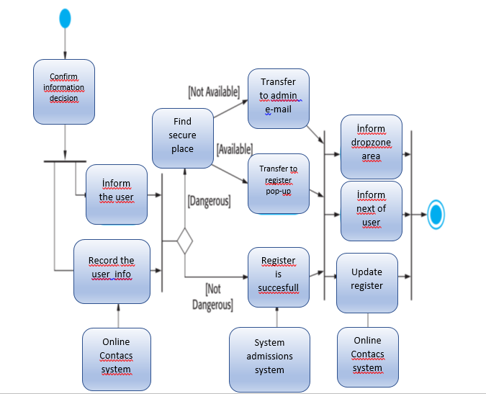

**14-Draw every use cases UML diagram of your project**

1 1

User Record

Admin

**15- Prepare tabular description of your projects’ use cases**

Table for transfer data:

|  |  |
| --- | --- |
|  |  |
| actors | Who is responsible for the user system |
| descriptıons | The user will have to write their personal information or open a new account if they are new. |
| data | User’s number and his photo. |
| stimulus | User command issued by the online contac system. |
| response  comments | Confirmation that the information and the numbers are updated.  The admin must have appropriate security permissions to access the user’ information. |

**16- Draw use cases of each agents’ use cases UML diagrams of your application**



administrator

**17- Draw Sequence diagrams of every action in your project**

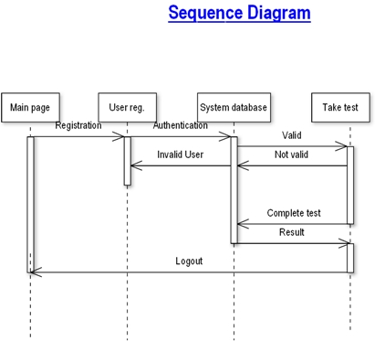

**18- Draw UML classes associations of all classes**

 

Admin-User The Contacs Sytem

**19- Draw class models**

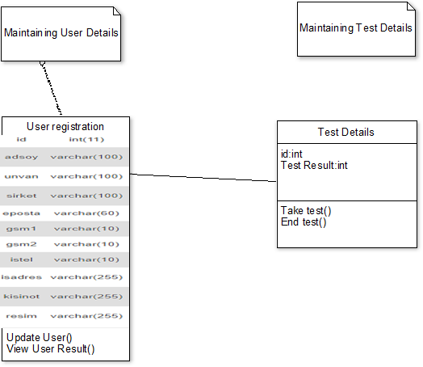

**20. Draw generalization hierarchy of your classes and all their details .**

System

Users

Admin

Users

id

ad soyad

unvan

şirket

e-posta

gsm1

istel

isadres

Admin

Controlling systems

**21. The Aggregation Association**

**Member**

**Record**

**1 1 1 1..* 1..* 1..\***

1

1

**User**

**User**

**Admin**

**Member**

**Admin**

**22. An Activity Model of The Patient Operation**

**Member:**

**Choose Photo**

**Get Id Value**

**Member Records**

**Member ID Data**

**Save and apply**

**Admin Data**

**Photo Data**

**Admin:**

**Choose Process**

**User number photo Data**

**Get Data**

**Add/Del**

**Added/Deleted /Update**

**23- Draw your application processes**



**24-Draw state diagram of your application**

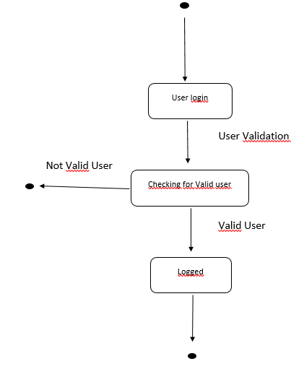

**25. States and Stimuli for the HMS**

|  |  |
| --- | --- |
| **State** | **Description** |
| Selecting | The System is waiting for input.The display shows the current process |
| Member | The user must be log in. User can see user information. |
| Admin | Admin is general manager. Admin can edit (add,update,delete)users(secretary,admin,medication). |
| Database | all inputs/outputs are collected here. The heart of the system. Patient information is saved here. Secretary and Doctor information is saved here. Data base is very important for HMS |

|  |  |
| --- | --- |
| **Stimulus** | **Description** |
| Admin | The user has selected the Admin section. |
| Log In | For user access to necessary places. |
| Add | Data is added to the database. |
| Control | Matches existing data in the database. |
| Process | The process is determined. Matched with the data in the database. |

26- **Draw the software architecture of your project**

**Input Process Output**

Register complated

Update Users

Query Member Information

Update Panel

Get Member ID information

Data

**27.System Context for the HMS**

1

1

1

1..n

1..n

1..n

1..n

1..n

**Admin**

**Member**

**Database**

**28.High-level Architecture of the HMS**

**Database**

**<<subsystem>>**

**Admin Collection**

**<<subsystem>> Member Manager**

**29- Draw all object classes of your project**

tableExport

dropzone

bootstrap-table

PHPExcel

General